Урок 15 beginner

**Давайте повторим изученное**

Мы знаем, как выразить типичное действие в настоящем (Present Simple):

V/v-s(-es), do/does, don’t/doesn’t

Мы умеем выразить типичное и однократное действие в прошлом, а также рассказать историю (Past Simple):

V-ed/V2,did+V, didn’t+V

Мы также можем показать недавнее действие, которое важно на момент говорения или подвести итог (Present Result):

Have+V3/V-ed

Мы можем рассказать, чем занимаемся в данный момент (Present Process):

Is/am/are+Ving

Но бывают моменты, когда нужно сказать, как долго мы уже делаем что либо. Здесь нам пригодится форма Present Process+Result.

present_process_result.mp4

present_process+result2.mp4

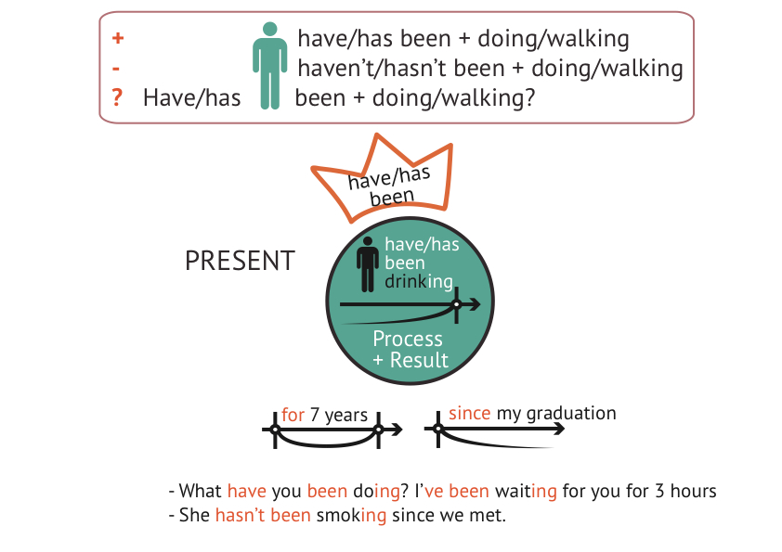

Употребите Present Process+Presult на практике.

Present Process + Result

patterny_Present_Process_result_obschaya_lexika.pdf

*I have been cooking since morning! – Я уже с утра готовлю!*

This is the way to inform about how long you have been doing something.

Также можно рассказать, как долго Вы выполняете какое-то действие в процессе приготовления пищи.

Картинки Еда

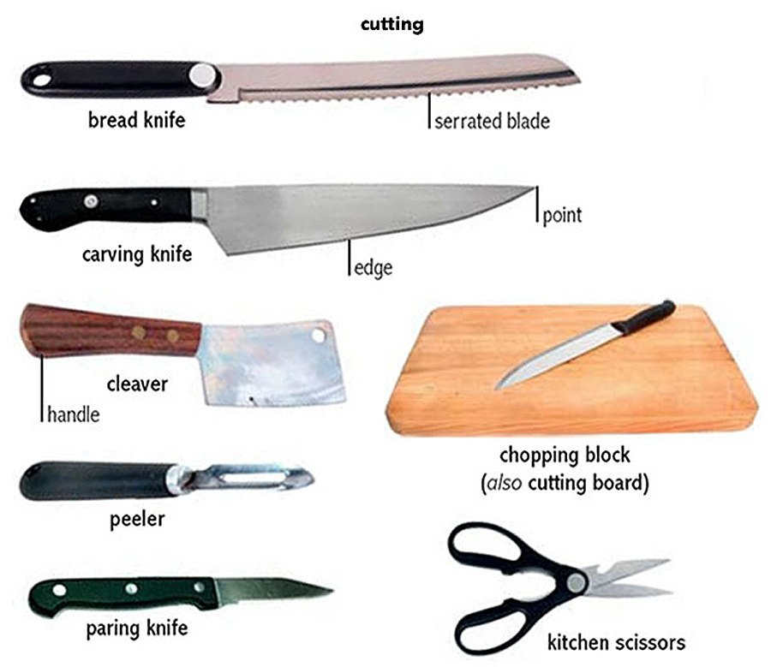

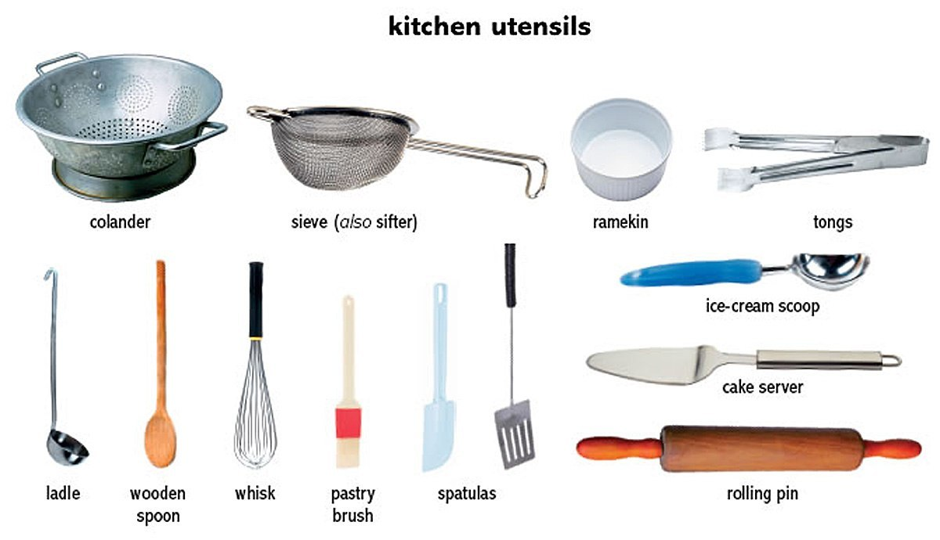 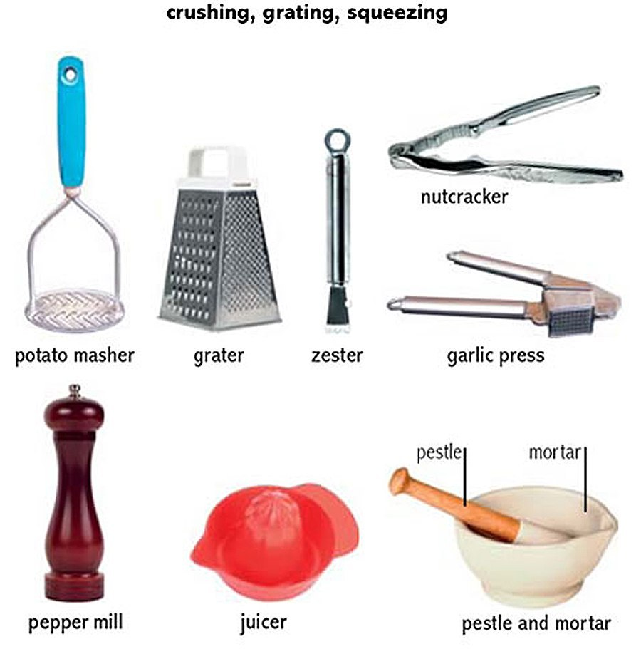 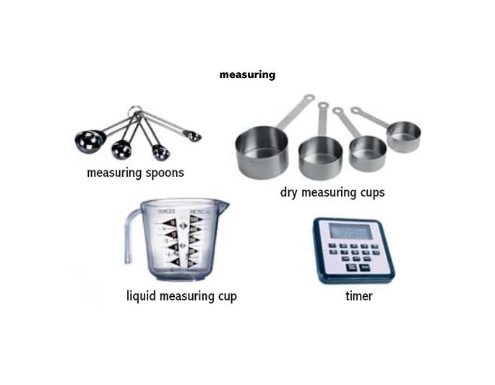 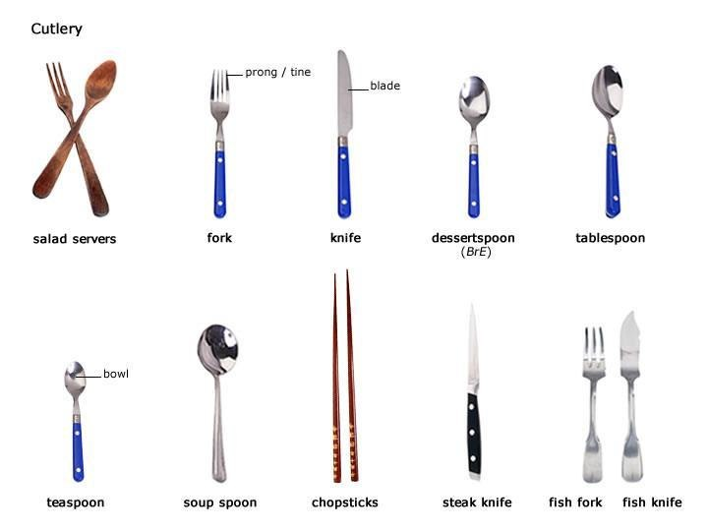 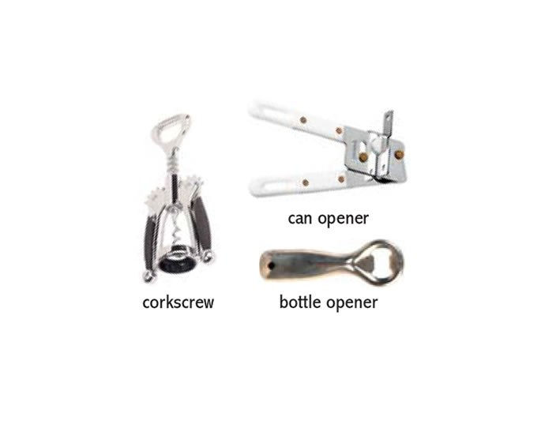

**Используйте эти слова в следующих паттернах:**

Паттерны Present Result Cooking

patterny_Present_Process_Result_cooking.pdf

Иногда изучающие язык люди спрашивают, как отличить Present Result и Present Process+ result. На самом деле, это абсолютно разные формы. Present Result передает законченное действие, а Present Process+result описывает действие, которое длится уже какое-то время.

**Посмотрите следующее видео на внешнем ресурсе:**

<http://www.engvid.com/english-grammar-present-perfect-simple-continuous/>

**Выполните паттерны на сравнение Present Result и Present Process+result.**

Паттерны Process_Process+Result

Patterny_Process_Process_Result.pdf

**Прочитайте текст.**

During the summer months, I often have a barbecue with my friends. I first put charcoal in the grill, pour some lighter fluid over the charcoal, and then light the grill with a match. It usually takes a few minutes for the grill to get going, and I don’t put the meat on until the coals are really hot. When the coals are ready, I put on the meat. Sometimes, I grill hamburgers, steak, or chicken. If I’m grilling steak, I lightly season the meat with salt and pepper, grill it on one side, and then turn over the meat and cook it on the other side. I generally like the meat medium rare, but most of my friends like their meat medium well. My brother likes his meat well-done. Sometimes, I also grill vegetables to add variety to the meal. Of course, some people use gas grills to barbecue their meal, but I prefer meat that is cooked over an open fire using charcoal.

**Прослушайте песню, вставьте недостающие слова в пропуски.**

Прослушайте песню Queen-Killer-Queen.mp3

|  |
| --- |
| Killer Queen |
| She keeps her Moet et Chandon  In her pretty _____  ‘let them eat _____’ she says  Just like Marie Antoinette  A built-in remedy  For Kruschev and Kennedy  At anytime an invitation  You can’t decline  ______ and cigarettes  Well versed in etiquette  Extraordinarily nice  She’s a Killer Queen  Gunpowder, gelatine  Dynamite with a laser beam  Guaranteed to blow your mind  Anytime  Ooh, recommended ______  Insatiable an ______  Wanna try?  To avoid complications  She never kept the same ______  In conversation  She spoke just like a baroness  Met a man from _____  Went down to Geisha Minah  (Killer, killer, she’s a killer Queen)  Then again incidentally  If you’re that way inclined  Perfume came naturally _______ (naturally)  For cars she couldn’t care less  Fastidious and precise  She’s a Killer _______  Gunpowder, gelatine  Dynamite with a laser beam  Guaranteed to blow your mind  Anytime  Drop of a hat she’s as willing as  Playful as _______  Then momentarily out of action  Temporarily out of gas  To absolutely drive you wild, wild..  She’s all out to get you  She’s a Killer Queen  Gunpowder, ________  Dynamite with a laser beam  Guaranteed to blow your mind  Anytime  Ooh, _______________  Insatiable an _____  Wanna try ?  You wanna try… |

 Проверьте себя

|  |
| --- |
| Killer Queen |
| She keeps her Moet et Chandon  In her pretty cabinet  ‘let them eat cake’ she says  Just like Marie Antoinette  A built-in remedy  For Kruschev and Kennedy  At anytime an invitation  You can’t decline  Caviar and cigarettes  Well versed in etiquette  Extraordinarily nice  She’s a Killer Queen  Gunpowder, gelatine  Dynamite with a laserbeam  Guaranteed to blow your mind  Anytime  Ooh, recommended at the price  Insatiable an appetite  Wanna try?  To avoid complications  She never kept the same address  In conversation  She spoke just like a baroness  Met a man from China  Went down to Geisha Minah  (Killer, killer, she’s a killer Queen)  Then again incidentally  If you’re that way inclined Perfume came naturally from Paris (naturally)  For cars she couldn’t care less  Fastidious and precise  She’s a Killer Queen  Gunpowder, gelatine  Dynamite with a laser beam  Guaranteed to blow your mind  Anytime  Drop of a hat she’s as willing as  Playful as a pussy cat  Then momentarily out of action  Temporarily out of gas  To absolutely drive you wild, wild..  She’s all out to get you  She’s a Killer Queen  Gunpowder, gelatine  Dynamite with a laser beam  Guaranteed to blow your mind  Anytime  Ooh, recommended at the price  Insatiable an appetite  Wanna try ?  You wanna try… |